Michael Durso

11/29/2018

Hotel Database

Oracle Final Project

Contents

**Database Overview** 2

Database Description 3

ER Diagram 5

**Table Descriptions** 6

Patient 7

Doctor 9

Nurse 10

Staff 11

Hospital 12

Building 13

Insurance 14

Admittance 15

Treatment 16

Equipment 17

Bill 18

**Queries** 19

Query1FinalEvery 20

Query2FinalOnly 22

Query3FinalNone 24

Query4FinalLeftJoin 25

Query5FinalRightJoin 26

Query6FinalFull 27

Query7Final -Six Table query 28

Query8Final 30

Query9Final 31

Query10Final 32

# 

# Database Overview

## Database Description

This Database is a model of a hospitals, what they are composed of, and how their components interact. This database will have multiple hospitals in it. Each hospital can be composed of one or more buildings as well. The purpose of the database is to organize not only a patient’s information but also the employee’s information and more. This database will handle many real-world applicable situations to gather necessary information.

Each table is minimized so that it does not have unnecessary data that would belong in a different table. Each table is related to the necessary other tables in order for the database to function correctly.

The Largest table with the most relations is the Patient table. This is because it has various information such as their name, their doctor’s name, what their insurance and more. Each piece of the table allows the table to connect to another. The Patient table relates to the doctor table in which a Doctor can have many patients but a Patient can have only one doctor. The relationship works the same with the Nurse table as it had with the Doctor. A Patient is also in a Building which is part of a certain Hospital, both of which are other tables. Another piece is the Bill which the Patient can have one bill for each time they are admitted and discharged from the hospital.

Before, the Hospital and Building tables were mentioned. A Hospital can have many Buildings but a Building can only belong to one particular Hospital. In addition, the Doctor’s and Nurse’s also belong to only one Building and Hospital.

The Staff table is used to define the varying salaries for the different job positions, the Doctor and the Nurse. The Staff table organizes the overall staff between all hospitals, buildings, and will describe the position and pay.

Every Treatment only has one piece of Equipment that will work for it but a piece of Equipment can be used for multiple Treatments. Both the Treatments and Equipment have costs that will get factored into the Bill at the end. Patients can have Insurance which will lower the total cost of the Bill as well.

## ER Diagram

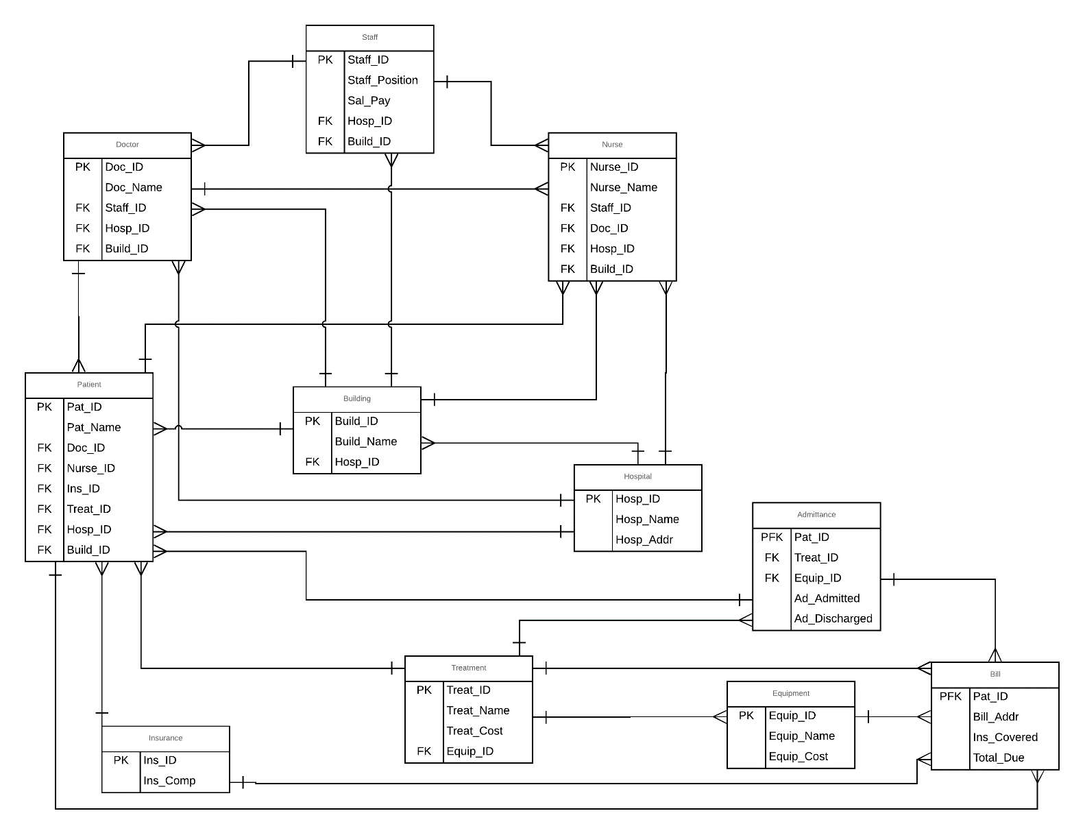

# 

# Table Descriptions

## Patient

The Patient table is the table the gives most of the patient’s data. Any information about the Patient that is not given in the Patient table itself is in another table through a relationship. For example the Patient’s billing address is not in this table but each patient has a bill and their address can be found there. This Patient table has one constraint for its primary which is the PAT_ID. There are also six constraints for the foreign keys which are: DOC_ID, NURSE_ID, INS_ID, TREAT_ID, HOSP_ID, BUILD_ID. These foreign keys give the ID’s of the patient’s doctor and nurse, their insurance company, treatment, the hospital they are in and which building in that hospital they are in.

CREATE TABLE FPATIENT

(

PAT_ID NUMBER(38,0) NOT NULL ENABLE,

PAT_NAME VARCHAR2(26 BYTE),

DOC_ID NUMBER(38,0),

NURSE_ID NUMBER(38,0),

INS_ID NUMBER(38,0),

TREAT_ID NUMBER(38,0),

HOSP_ID NUMBER(38,0),

BUILD_ID NUMBER(38,0),

CONSTRAINT FPATIENT_PK PRIMARY KEY (PAT_ID)

CONSTRAINT FK_DOC_ID FOREIGN KEY (DOC_ID) REFERENCES FDOCTOR (DOC_ID),

CONSTRAINT FK_NURSE_ID FOREIGN KEY (NURSE_ID) REFERENCES FNURSE (NURSE_ID),

CONSTRAINT FK_INSID FOREIGN KEY (INS_ID) REFERENCES FINSURANCE (INS_ID),

CONSTRAINT FK_TREATID FOREIGN KEY (TREAT_ID) REFERENCES FTREATMENT (TREAT_ID),

CONSTRAINT FK_HOSP_I_D_ FOREIGN KEY (HOSP_ID) REFERENCES FHOSPITAL (HOSP_ID),

CONSTRAINT FK_BUILD_I_D_ FOREIGN KEY (BUILD_ID) REFERENCES FBUILDING (BUILD_ID)

);

**Third Normal Form Justification:**

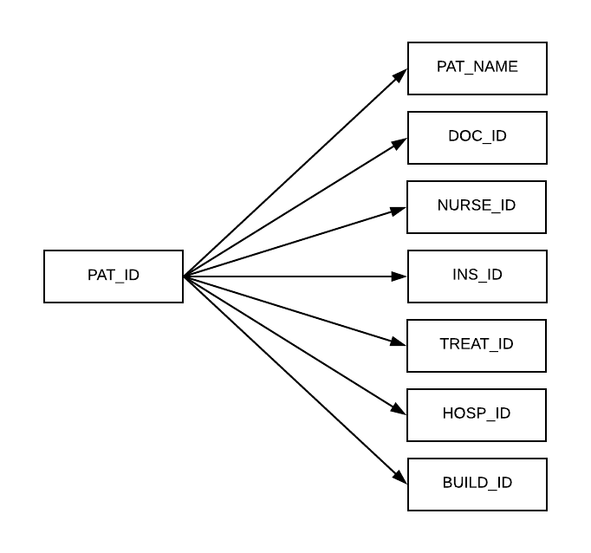

## Doctor

The Doctor table is most of the doctor’s information. It keeps track of all of the doctor’s IDs and names. They are also given a Staff ID so they can be recorded in the Staff table. They also have Hospital and Building IDs so that it is recorded which ones they are correlated with. There is one constraint for the primary key which is the DOC_ID. There are also three constraints for the foreign keys which are STAFF_ID, HOSP_ID, BUILD_ID.

CREATE TABLE FDOCTOR

(

DOC_ID NUMBER(38,0) NOT NULL ENABLE,

DOC_NAME VARCHAR2(26 BYTE),

STAFF_ID NUMBER(38,0),

HOSP_ID NUMBER(38,0),

BUILD_ID NUMBER(38,0),

CONSTRAINT FDOCTOR_PK PRIMARY KEY (DOC_ID),

CONSTRAINT FK_STAFFID FOREIGN KEY (STAFF_ID) REFERENCES FSTAFF (STAFF_ID),

CONSTRAINT FK_HOSPID" FOREIGN KEY (HOSP_ID) REFERENCES FHOSPITAL (HOSP_ID),

CONSTRAINT FK_BUILDID" FOREIGN KEY (BUILD_ID) REFERENCES FBUILDING (BUILD_ID)

);

**Third Normal Form Justification:**

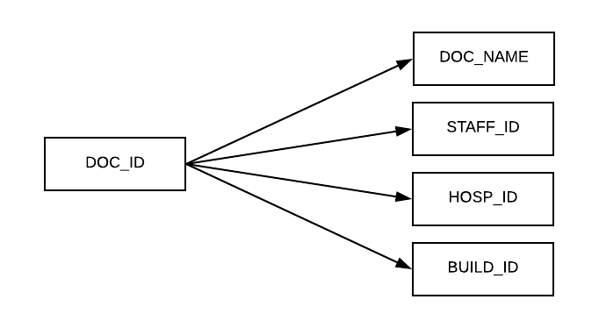

## Nurse

The Nurse table is very similar to that of the Doctor table. Every foreign key is the same except there is a fourth additional foreign key which is the DOC_ID. This keeps track of which doctor that this specific nurse is working under. This table has the primary constraint being the NURSE_ID. Every nurse has a NURSE_ID and a NURSE_NAME much like the doctors have a DOC_ID and DOC_NAME.

CREATE TABLE FNURSE

(

NURSE_ID NUMBER(38,0) NOT NULL ENABLE,

NURSE_NAME VARCHAR2(26 BYTE),

STAFF_ID NUMBER(38,0),

DOC_ID NUMBER(38,0),

HOSP_ID NUMBER(38,0),

BUILD_ID NUMBER(38,0),

CONSTRAINT FNURSE_PK PRIMARY KEY (NURSE_ID),

CONSTRAINT FK_STAFF_ID FOREIGN KEY (STAFF_ID) REFERENCES FSTAFF (STAFF_ID),

CONSTRAINT FK_DOCID FOREIGN KEY (DOC_ID) REFERENCES FDOCTOR (DOC_ID),

CONSTRAINT FK_HOSP_ID FOREIGN KEY (HOSP_ID) REFERENCES FHOSPITAL (HOSP_ID),

CONSTRAINT FK_BUILD_ID FOREIGN KEY (BUILD_ID) REFERENCES FBUILDING (BUILD_ID)

);

**Third Normal Form Justification:**

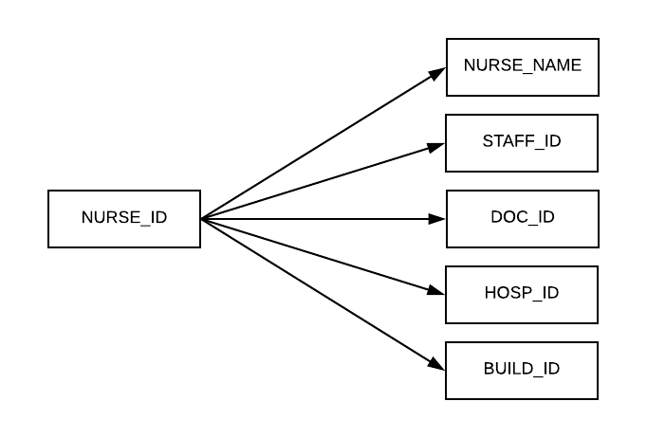

## Staff

The Staff table is used to keep track of every employee, regardless of their position, building, or hospital. The Staff table also determines and keeps track of the staff’s salary. There is one constraint for the primary key which is the STAFF_ID. There are two constraints for foreign keys which are the HOSP_ID and BUILD_ID.

CREATE TABLE FSTAFF

(

STAFF_ID NUMBER(38,0) NOT NULL ENABLE,

STAFF_POSITION VARCHAR2(26 BYTE),

SAL_PAY NUMBER(38,0),

HOSP_ID NUMBER(38,0),

BUILD_ID NUMBER(38,0),

CONSTRAINT FSTAFF_PK PRIMARY KEY (STAFF_ID),

CONSTRAINT F_K_HOSP_ID FOREIGN KEY (HOSP_ID) REFERENCES FHOSPITAL (HOSP_ID),

CONSTRAINT F_K_BUILD_ID FOREIGN KEY (BUILD_ID) REFERENCES FBUILDING (BUILD_ID)

);

**Third Normal Form Justification:**

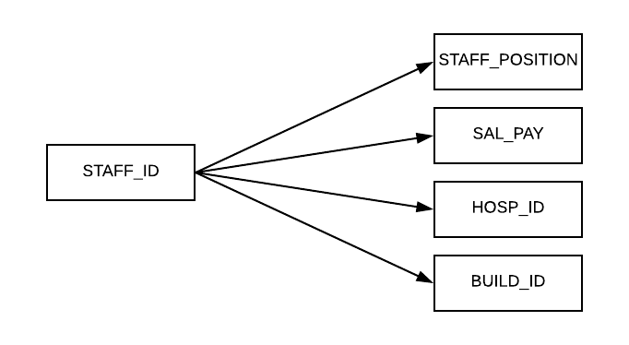

## Hospital

The Hospital table is used to keep track of the different hospitals that are in the database. Aside from the hospital’s ID and name there is also a hospital address. The primary key constraint is the only constraint for this table which is the HOSP_ID.

CREATE TABLE FHOSPITAL

(

HOSP_ID NUMBER(38,0) NOT NULL ENABLE,

HOSP_NAME VARCHAR2(26 BYTE),

HOSP_ADDR VARCHAR2(26 BYTE),

CONSTRAINT FHOSPITAL_PK PRIMARY KEY (HOSP_ID)

);

**Third Normal Form Justification:**

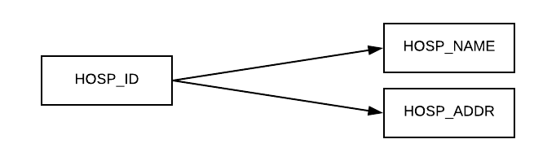

## Building

The Building table is similar to that of the Hospital table. There is a given building ID and name. There is also a hospital ID given so it is clear which hospital this building is a part of. There is a constraint for the primary key which is the BUILD_ID. There is also a constraint for the Foreign key which is the HOSP_ID.

CREATE TABLE FBUILDING

(

HOSP_ID NUMBER(38,0),

BUILD_ID NUMBER(38,0) NOT NULL ENABLE,

BUILD_NAME VARCHAR2(26 BYTE),

CONSTRAINT FBUILDING_PK PRIMARY KEY (BUILD_ID)

CONSTRAINT F_K_HOSP_I_D FOREIGN KEY (HOSP_ID) REFERENCES FHOSPITAL (HOSP_ID)

);

**Third Normal Form Justification:**

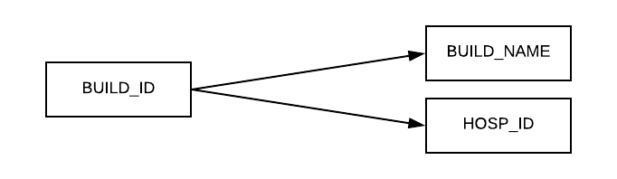

## Insurance

The Insurance table is used to simply keep track of the various Insurance companies that the patients could potentially have. The Patient table is connected here via the INS_ID which is the primary key and only constraint on this table. It is possible for there to be nulls in the patients INS_ID record if they do not have insurance. (“No insurance” is not a value in this table instead nulls are used in the patient table).

CREATE TABLE FINSURANCE

(

INS_ID NUMBER(38,0) NOT NULL ENABLE,

INS_COMP VARCHAR2(26 BYTE),

CONSTRAINT FINSURANCE_PK PRIMARY KEY (INS_ID)

);

**Third Normal Form Justification:**

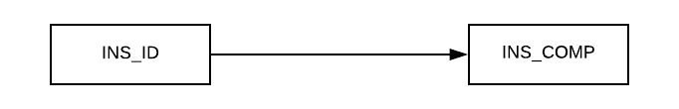

## Admittance

The Admittance table is used mainly to track when the patients were admitted to the hospital as well as if/when they are discharged from the hospital. It also adds the EQUIP_ID and TREAT_ID which are two of the table’s foreign keys. This is listed here so that we can see what the particular patients needed treatment wise and what equipment was needed for the treatments. The primary key is also a foreign key and is the PAT_ID.

CREATE TABLE FADDMITANCE

(

PAT_ID NUMBER(38,0) NOT NULL ENABLE,

TREAT_ID NUMBER(38,0),

EQUIP_ID NUMBER(38,0),

ADD_ADDMITTED DATE,

ADD_DISCHARGED DATE,

CONSTRAINT FADDMITANCE_PK PRIMARY KEY (PAT_ID),

CONSTRAINT FK_PAT_ID FOREIGN KEY (PAT_ID) REFERENCES FPATIENT (PAT_ID),

CONSTRAINT FK_TREAT_ID FOREIGN KEY (TREAT_ID) REFERENCES FTREATMENT (TREAT_ID),

CONSTRAINT FK_EQUIP_I_D FOREIGN KEY (EQUIP_ID) REFERENCES FEQUIPMENT (EQUIP_ID)

);

**Third Normal Form Justification:**

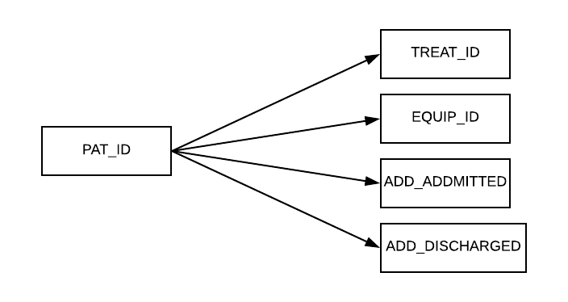

## Treatment

The Treatment table is to organize the various aspects of what goes into a treatment. Each treatment is identified by the primary key which is the TREAT_ID. Along with the id is the treatments name. The TREAT_COST is located here but is factored into the total amount of the bill. The EQUIP_ID is a foreign key here because treatments need to have certain equipment that correspond to it.

CREATE TABLE FTREATMENT

(

TREAT_ID NUMBER(38,0) NOT NULL ENABLE,

TREAT_NAME VARCHAR2(26 BYTE),

TREAT_COST NUMBER(38,0),

EQUIP_ID NUMBER(38,0),

CONSTRAINT FTREATMENT_PK PRIMARY KEY (TREAT_ID),

CONSTRAINT FK_EQUIP_ID FOREIGN KEY (EQUIP_ID) REFERENCES FEQUIPMENT (EQUIP_ID)

);

**Third Normal Form Justification:**

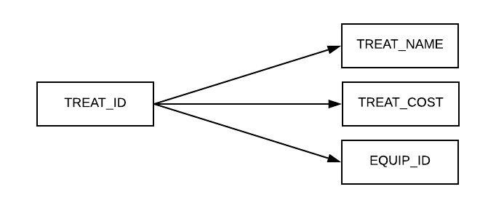

## Equipment

The Equipment table is used to identify equipment and its cost that will get factored into the patient’s bill. The EQUIP_ID is the primary key as well as the only constraint for this table. The EQUIP_NAME is also included.

CREATE TABLE FEQUIPMENT

(

EQUIP_ID NUMBER(38,0) NOT NULL ENABLE,

EQUIP_NAME VARCHAR2(26 BYTE),

EQUIP_COST NUMBER(38,0),

CONSTRAINT FEQUIPMENT_PK PRIMARY KEY (EQUIP_ID)

);

**Third Normal Form Justification:**

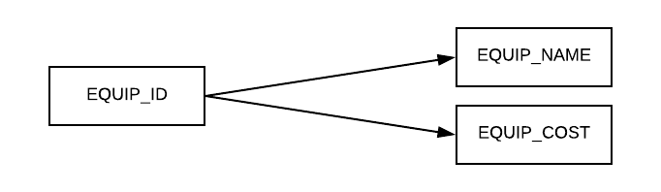

## Bill

The Bill is used to tie together more Patient information that is not directly given in the patient table. This is separate because the information here is indirectly about the patient but more about how the information can appear on the bill. The PAT_ID makes up the two constraint for this table since it is the primary key as well as a foreign key. The patients billing addresses are listed here. This is where it is shown whether or not the insurance covered any, all, or none of the TOTAL_DUE.

CREATE TABLE FBILL

(

PAT_ID NUMBER(38,0) NOT NULL ENABLE,

BILL_ADDR VARCHAR2(26 BYTE),

DOCTOR_COST NUMBER(38,0),

INS_COVERED NUMBER(38,2),

TOTAL_DUE NUMBER(38,2),

CONSTRAINT FBILL_PK PRIMARY KEY (PAT_ID),

CONSTRAINT FK_PAT_ID_ FOREIGN KEY (PAT_ID) REFERENCES FPATIENT (PAT_ID)

);

**Third Normal Form Justification:**

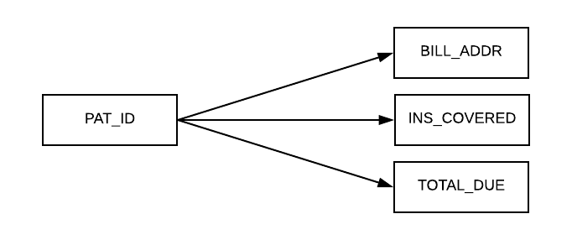

# Queries

## Query1FinalEvery

**English statement:**

For every patient that is in building Foy get the hospital name

**SQL:**

SELECT fpatient.pat_name

FROM fpatient

WHERE NOT EXISTS

(SELECT *

FROM fbuilding

WHERE fbuilding.build_name = 'Foy'

AND NOT EXISTS

(SELECT *

FROM fhospital

WHERE fbuilding.hosp_id = fhospital.hosp_id));

**Table:**

|  |
| --- |
| **PAT_NAME** |
| Sam Beson |
| Sam Berenberg |
| Nico Agostini |
| Tobi Omotoso |
| Matt Gronert |
| Laura Tucker |
| Chris Lauria |
| Ben Mazza |
| Michael Leitner |
| Pat Dilloin |
| Ethan Black |
| Jack Andrus |
| Scottie German |
| Jared Babsky |
| Laura Moelis |
| Amy Sky |
| Matt Kretz |
| Chris Ravosa |
| Miller Fink |
| Luke Skywalker |
| Han Solo |
| Indiana Jones |
| Boba Fett |
| Chuck Kautz |
| Kaitlyn Durso |
| Andrew Crawford |
| Sarah Crawford |
| Larry David |
| Jerry Seinfeld |
| Arthur Morgan |

**Cardinality:** 30

## Query2FinalOnly

**English Statement:**

Name the staff who are only nurses in a hospital other than Monmouth Medical.

**SQL:**

SELECT fstaff.staff_id

FROM fstaff

WHERE fstaff.staff_id NOT IN(

SELECT fdoctor.staff_id

FROM fdoctor

WHERE fdoctor.hosp_id NOT IN(

SELECT fhospital.hosp_id

FROM fhospital

WHERE fhospital.hosp_name = 'Monmouth Medical'));

**Table:**

|  |
| --- |
| **STAFF_ID** |
| 2016 |
| 2017 |
| 2015 |
| 2011 |
| 2002 |
| 2010 |
| 2014 |
| 2008 |
| 2005 |
| 2018 |
| 2001 |
| 2007 |
| 2012 |
| 2013 |
| 2019 |
| 2003 |
| 1001 |
| 2006 |
| 1002 |
| 2009 |
| 2020 |
| 2004 |

**Cardinality:** 22

## Query3FinalNone

**English Statement:**

Name patients not in Jersey Shore.

**SQL:**

SELECT fpatient.pat_name

FROM fpatient

WHERE fpatient.hosp_id NOT IN(

SELECT fhospital.hosp_id

FROM fhospital

WHERE fhospital.hosp_name = 'Jersey Shore');

**Table:**

|  |
| --- |
| **PAT_NAME** |
| Arthur Morgan |
| Jerry Seinfeld |
| Larry David |
| Sarah Crawford |
| Andrew Crawford |
| Kaitlyn Durso |
| Chuck Kautz |
| Boba Fett |
| Indiana Jones |
| Ben Mazza |
| Chris Lauria |
| Laura Tucker |
| Matt Gronert |
| Tobi Omotoso |
| Nico Agostini |
| Sam Berenberg |
| Sam Beson |

**Cardinality:** 17

## Query4FinalLeftJoin

**English Statement:**

Give all patient names along with the name of their Insurance company if any.

**SQL:**

SELECT fpatient.pat_name, finsurance.ins_id, finsurance.ins_comp

FROM fpatient LEFT JOIN finsurance ON fpatient.ins_id = finsurance.ins_id;

**Table:**

|  |  |  |
| --- | --- | --- |
| **PAT_NAME** | **INS_ID** | **INS_COMP** |
| Jerry Seinfeld | 100 | Blue Cross Blue Shield |
| Chuck Kautz | 100 | Blue Cross Blue Shield |
| Boba Fett | 100 | Blue Cross Blue Shield |
| Matt Kretz | 100 | Blue Cross Blue Shield |
| Ethan Black | 100 | Blue Cross Blue Shield |
| Nico Agostini | 100 | Blue Cross Blue Shield |
| Sam Beson | 100 | Blue Cross Blue Shield |
| Arthur Morgan | 200 | Anthem |
| Sarah Crawford | 200 | Anthem |
| Kaitlyn Durso | 200 | Anthem |
| Indiana Jones | 200 | Anthem |
| Han Solo | 200 | Anthem |
| Jack Andrus | 200 | Anthem |
| Pat Dilloin | 200 | Anthem |
| Michael Leitner | 200 | Anthem |
| Tobi Omotoso | 200 | Anthem |
| Sam Berenberg | 200 | Anthem |
| Andrew Crawford | 300 | United Healthcare |
| Scottie German | 300 | United Healthcare |
| Ben Mazza | 300 | United Healthcare |
| Laura Tucker | 300 | United Healthcare |
| Matt Gronert | 300 | United Healthcare |
| Larry David | 400 | Highmark |
| Miller Fink | 400 | Highmark |
| Chris Ravosa | 400 | Highmark |
| Jared Babsky | 400 | Highmark |
| Chris Lauria | 400 | Highmark |
| Luke Skywalker | (null) | (null) |
| Amy Sky | (null) | (null) |
| Laura Moelis | (null) | (null) |

**Cardinality:** 30

## Query5FinalRightJoin

**English Statement:**

Give all Patient names and their discharge date if any.

**SQL:**

SELECT faddmitance.add_discharged, fpatient.pat_name, faddmitance.pat_id

FROM fpatient RIGHT JOIN faddmitance ON fpatient.pat_id = faddmitance.pat_id;

**Table:**

|  |  |  |
| --- | --- | --- |
| **ADD_DISCHARGED** | **PAT_NAME** | **PAT_ID** |
| 10-JAN-19 | Sam Beson | 1 |
| 01-MAR-19 | Sam Berenberg | 2 |
| 10-JAN-19 | Nico Agostini | 3 |
| 03-NOV-18 | Tobi Omotoso | 4 |
| 06-JUL-18 | Matt Gronert | 5 |
| 19-JAN-18 | Laura Tucker | 6 |
| 24-JAN-18 | Chris Lauria | 7 |
| 06-DEC-18 | Ben Mazza | 8 |
| 04-MAR-18 | Michael Leitner | 9 |
| 12-MAY-18 | Pat Dilloin | 10 |
| 12-MAY-18 | Ethan Black | 11 |
| 11-JUL-18 | Jack Andrus | 12 |
| 16-MAY-18 | Scottie German | 13 |
| 16-MAY-18 | Jared Babsky | 14 |
| (null) | Laura Moelis | 15 |
| 19-NOV-18 | Amy Sky | 16 |
| 17-NOV-18 | Matt Kretz | 17 |
| 09-AUG-18 | Chris Ravosa | 18 |
| 19-JUL-18 | Miller Fink | 19 |
| 26-AUG-18 | Luke Skywalker | 20 |
| 01-MAR-18 | Han Solo | 21 |
| 29-JUL-18 | Indiana Jones | 22 |
| 24-DEC-18 | Boba Fett | 23 |
| 31-OCT-18 | Chuck Kautz | 24 |
| 01-AUG-18 | Kaitlyn Durso | 25 |
| 02-AUG-18 | Andrew Crawford | 26 |
| 07-AUG-18 | Sarah Crawford | 27 |
| (null) | Larry David | 28 |
| 26-OCT-18 | Jerry Seinfeld | 29 |
| 03-SEP-19 | Arthur Morgan | 30 |

**Cardinality:** 30

## Query6FinalFull

**English Statement:**

Give all Patient names along with Doctor IDs and Names if any.

**SQL:**

SELECT fpatient.pat_name, fdoctor.doc_id, fdoctor.doc_name

FROM fpatient FULL JOIN fdoctor ON fpatient.doc_id = fdoctor.doc_id;

**Table:**

|  |  |  |
| --- | --- | --- |
| **PAT_NAME** | **DOC_ID** | **DOC_NAME** |
| Sam Beson | 111 | Bob Kelso |
| Sam Berenberg | 111 | Bob Kelso |
| Nico Agostini | 111 | Bob Kelso |
| Tobi Omotoso | 111 | Bob Kelso |
| Matt Gronert | 111 | Bob Kelso |
| Laura Tucker | 112 | Elliot Reid |
| Chris Lauria | 112 | Elliot Reid |
| Ben Mazza | 112 | Elliot Reid |
| Michael Leitner | 113 | Perry Cox |
| Pat Dilloin | 113 | Perry Cox |
| Ethan Black | 113 | Perry Cox |
| Jack Andrus | 113 | Perry Cox |
| Scottie German | 113 | Perry Cox |
| Jared Babsky | 113 | Perry Cox |
| Laura Moelis | (null) | (null) |
| Amy Sky | 114 | John Dorian |
| Matt Kretz | 114 | John Dorian |
| Chris Ravosa | 114 | John Dorian |
| Miller Fink | 114 | John Dorian |
| Luke Skywalker | 115 | Ross Geller |
| Han Solo | 115 | Ross Geller |
| Indiana Jones | 116 | Rachel Green |
| Boba Fett | 117 | Monica Geller |
| Chuck Kautz | 117 | Monica Geller |
| Kaitlyn Durso | 118 | Chandler Bing |
| Andrew Crawford | 118 | Chandler Bing |
| Sarah Crawford | 118 | Chandler Bing |
| Larry David | (null) | (null) |
| Jerry Seinfeld | 120 | Joey Tribbiani |
| Arthur Morgan | 120 | Joey Tribbiani |
| (null) | 119 | Phoebe Buffay |

**Cardinality:** 31

## Query7Final -Six Table query

**English Statement:**

For every patient give their name and the name of their doctor, nurse, hospital, building, and insurance company.

**SQL:**

SELECT fpatient.pat_name, fdoctor.doc_name, fnurse.nurse_name, fhospital.hosp_name, fbuilding.build_name, finsurance.ins_comp

FROM fpatient, fdoctor, fnurse, fhospital, fbuilding, finsurance

WHERE fpatient.doc_id = fdoctor.doc_id

AND fpatient.nurse_id = fnurse.nurse_id

AND fpatient.hosp_id = fhospital.hosp_id

AND fpatient.build_id = fbuilding.build_id

AND fpatient.ins_id = finsurance.ins_id;

**Table:**

|  |  |  |  |  |  |
| --- | --- | --- | --- | --- | --- |
| **PAT_NAME** | **DOC_NAME** | **NURSE_NAME** | **HOSP_NAME** | **BUILD_NAME** | **INS_COMP** |
| Sam Berenberg | Bob Kelso | Jon Snow | Monmouth Medical | Marian | Anthem |
| Sam Beson | Bob Kelso | Jon Snow | Monmouth Medical | Marian | Blue Cross Blue Shield |
| Nico Agostini | Bob Kelso | Jon Snow | Monmouth Medical | Marian | Blue Cross Blue Shield |
| Matt Gronert | Bob Kelso | Kit Harrington | Monmouth Medical | Marian | United Healthcare |
| Tobi Omotoso | Bob Kelso | Kit Harrington | Monmouth Medical | Marian | Anthem |
| Laura Tucker | Elliot Reid | Emilia Clarke | Monmouth Medical | Champ | United Healthcare |
| Chris Lauria | Elliot Reid | Sophie Turner | Monmouth Medical | Champ | Highmark |
| Ben Mazza | Elliot Reid | Arya Stark | Monmouth Medical | Champ | United Healthcare |
| Matt Kretz | John Dorian | Peter Dinklage | Jersey Shore | Foy | Blue Cross Blue Shield |
| Chris Ravosa | John Dorian | Tyrion Lannister | Jersey Shore | Foy | Highmark |
| Miller Fink | John Dorian | Tyrion Lannister | Jersey Shore | Foy | Highmark |
| Han Solo | Ross Geller | Samwell Tarly | Jersey Shore | Fulton | Anthem |
| Indiana Jones | Rachel Green | Khal Drogo | Sacred Heart | Foxrun | Anthem |
| Boba Fett | Monica Geller | Richard Madden | Sacred Heart | Hancock | Blue Cross Blue Shield |
| Chuck Kautz | Monica Geller | Jack Gleeson | Sacred Heart | Hancock | Blue Cross Blue Shield |
| Andrew Crawford | Chandler Bing | Sean Bean | Sacred Heart | Dyson | United Healthcare |
| Kaitlyn Durso | Chandler Bing | Sean Bean | Sacred Heart | Dyson | Anthem |
| Sarah Crawford | Chandler Bing | Joe Dempsie | Sacred Heart | Dyson | Anthem |
| Jerry Seinfeld | Joey Tribbiani | Theon Greyjoy | Sacred Heart | Winterfell | Blue Cross Blue Shield |
| Arthur Morgan | Joey Tribbiani | Hodor Bronn | Sacred Heart | Winterfell | Anthem |

**Cardinality:** 20

## Query8Final

**English Statement:**

name the doctors that have at least one patient with the insurance Blue Cross Blue Shield

**SQL:**

SELECT DISTINCT fdoctor.doc_name

FROM fdoctor, fpatient, finsurance

WHERE fdoctor.doc_id = fpatient.doc_id

AND fpatient.ins_id = finsurance.ins_id

AND finsurance.ins_comp = 'Blue Cross Blue Shield';

**Table:**

|  |
| --- |
| **DOC_NAME** |
| John Dorian |
| Joey Tribbiani |
| Perry Cox |
| Bob Kelso |
| Monica Geller |

**Cardinality:** 5

## Query9Final

**English Statement:**

Get Patient IDs and Names for those who have a lower total bill than Ben Mazza.

**SQL:**

SELECT patient2.pat_id, patient2.pat_name

FROM fpatient patient1, fpatient patient2, fbill bill1, fbill bill2

WHERE patient1.pat_name = 'Ben Mazza'

AND patient1.pat_id = bill1.pat_id

AND patient2.pat_id = bill2.pat_id

AND bill1.total_due < bill2.total_due;

**Table:**

|  |  |
| --- | --- |
| **PAT_ID** | **PAT_NAME** |
| 2 | Sam Berenberg |
| 3 | Nico Agostini |
| 4 | Tobi Omotoso |
| 13 | Scottie German |
| 15 | Laura Moelis |
| 16 | Amy Sky |
| 20 | Luke Skywalker |
| 22 | Indiana Jones |
| 23 | Boba Fett |
| 29 | Jerry Seinfeld |

**Cardinality:** 10

## Query10Final

**English Statement:**

Get the Nurse's ID and Name that is first in the alphabetic list of of the other nurses.(by first name)

**SQL:**

SELECT fnurse.nurse_ID, fnurse.nurse_name

FROM fnurse

WHERE fnurse.nurse_name IN

(SELECT MIN(fnurse.nurse_name)

FROM fnurse);

**Table:**

|  |  |
| --- | --- |
| **NURSE_ID** | **NURSE_NAME** |
| 205 | Arya Stark |

**Cardinality:** 1